**Class Exercise 7 Output – 1-4:**

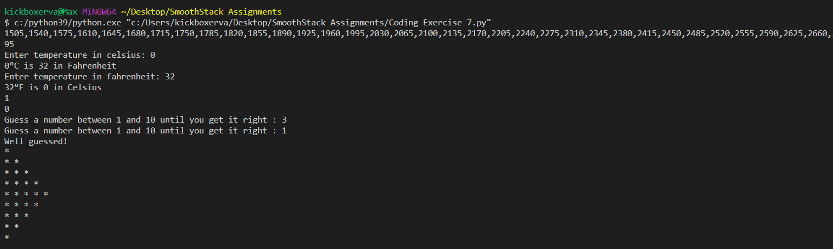

**Class Exercise 7 Output – 5-9:**

**Class Exercise 8 Output:**

